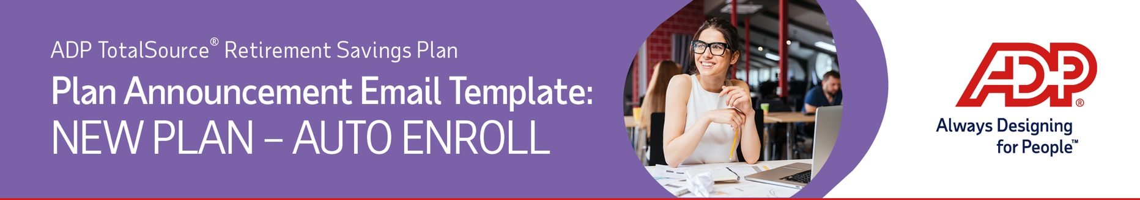
Follow the instructions below to create an email and PDF attachment of the ADP TotalSource® Retirement Savings Plan (the “Plan”) information to send all of your employees. The email will welcome them to the Plan.
Use this template if you are starting a new plan with ADP TotalSource.
- Save a copy of the Word template to your desktop. Open the template to print a copy of the instructions. Refer to them when completing the template and sending the email to your employees.
- Copy and paste the following into the subject line of a new email:
Important 401(k) Plan Information
Copy the content below into the body of the email. Fill in the plan effective date and change the font color to black.

We are pleased to inform you that effective DATE, we are providing you with a new retirement plan benefit, the ADP TotalSource Retirement Savings Plan at Voya Financial. Please see the attached document for additional information.
- On the template (page 2), fill in your company name and change the font color to black.
Delete the instructions page.
- Create a PDF of the template by going to File > Export > Create Adobe PDF and follow the prompts.
- Attach the saved PDF to your email and send it to all of your employees.

ADP, the ADP logo, ADP TotalSource and Always Designing for People are trademarks of ADP, Inc. Copyright © 2026. All rights reserved.
3684486_0126 ©2026 Voya Services Company. All rights reserved.
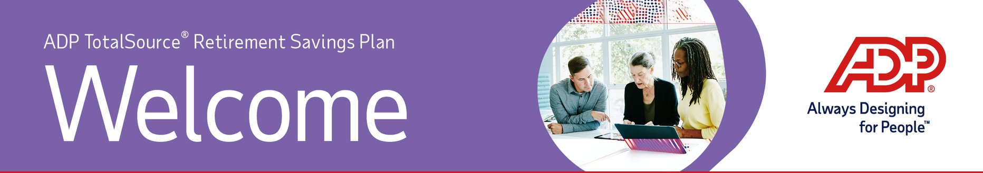
Welcome to the ADP TotalSource Retirement Savings Plan!
Eligible employees will receive enrollment materials from Voya. Once received, you can enroll by:
Web - There are two ways to access your Plan account online.*
- Visit the Associate Portal and log in with your username and password. Then click the Myself tab and select Retirement Plan under Benefits.
- Or log in to the Plan website at https://adptotalsource.voya.com
Mobile - Search ADP Mobile App or Voya Retire* in your preferred mobile app store.

Information Line - Call the Plan Service Center at (855) 646-7549 and press 0 to speak with a Customer Service Associate. They are available from 8:00 a.m. to 8:00 p.m. Eastern Time, Monday through Friday (excluding New York Stock Exchange holidays).
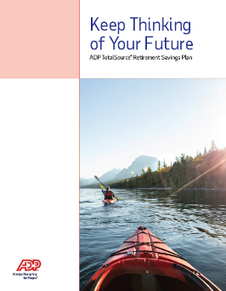
If you do not enroll on your own or choose to decline enrollment by the opt out date printed on the back of your enrollment guide, you will be automatically enrolled where the contribution percentage and investment option are chosen for you. New contributions will be invested in the plan's default fund, the Voya Target Solution Trust Fund, based on your date of birth and your projected retirement age of 65. Remember, you can change your investments at any time.
To learn more about the specific features of your plan, please review the Enrollment Guide that you received either via email or mail. Additional resources regarding your plan are located on the Participant Resources website.
Thank you,
COMPANY NAME
*Log into the Plan website, click the Register Now button and follow the step-by-step prompts to receive a PIN and register your account. Once you’ve created a username and password, you will be brought back to login screen. Log in using these credentials. Your unique login credentials will also be used for the Voya Retire mobile app.

Generally speaking,Target Date funds target a certain date range for retirement, or the date the investor plans to start withdrawing money. Investors can select the fund that corresponds to their target date. They are designed to rebalance to a more conservative approach as the date nears. An investment in the Target Date fund is not guaranteed at any time, including on or after the target date.

