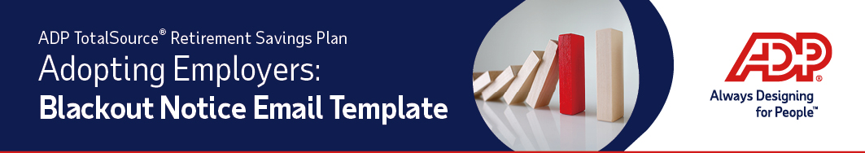
Follow the instructions below to create an email and PDF attachment of the ADP TotalSource® Retirement Savings Plan (the “Plan”) information to send all of your employees. The email will inform them of the recordkeeper change and notify them of the blackout period.
- Copy and paste the following into the subject line of a new email. Change the font color to black.
Important Notice Concerning your Rights under the PLAN NAME
Copy and paste the following into the body of the email:
We are pleased to inform you that our prior company 401(k) plan will be merging into the ADP TotalSource Retirement Savings Plan at Voya Financial. As a result, there will be a blackout period during which the transfer will occur and you will be unable to access your prior plan account. It is very important that you carefully read the attached Blackout Notice for information about when your 401(k) plan account will transfer to the ADP TotalSource Retirement Savings Plan.
- Attach the Blackout Notice PDF that was provided to you by Voya, to your email and send it to all of your employees and participants with a balance in your prior plan.

