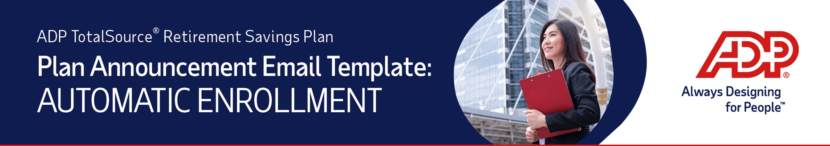
Follow the instructions below to create an email and PDF attachment of the ADP TotalSource® Retirement Savings Plan (the “Plan”) information to send to all your eligible employees. The email will notify them that the plan has an Automatic Enrollment feature and explain how it works.
Use this template if your plan is adding an Automatic Enrollment feature in the near future.
- Save a copy of the Word template to your desktop. Open the template to print a copy of the instructions. Refer to them when completing the template and sending the email to your employees.
- Copy and paste the following into the subject line of a new email:
Important 401(k) Plan Information – Please review for action
Copy the content below into the body of the email. Fill in the plan effective date and remove the yellow highlight.

We are pleased to inform you that effective DATE, an automatic enrollment feature has been added to the 401(k) plan. This feature makes it easier for you to support your retirement savings and planning goals.
Please see the attached document for additional information.

- On the template below (page 2), there are two items highlighted in yellow. Replace the highlighted “X” with the automatic enrollment percentage for your plan. Remove the highlighted Automatic Deferral Increase section if your plan does not have this feature. Then, remove the highlight.
- Delete these instructions.
- Create a PDF of the template by going to File > Export > Create Adobe PDF and follow the prompts.
- Attach the saved PDF to your email and send it to your eligible employees.
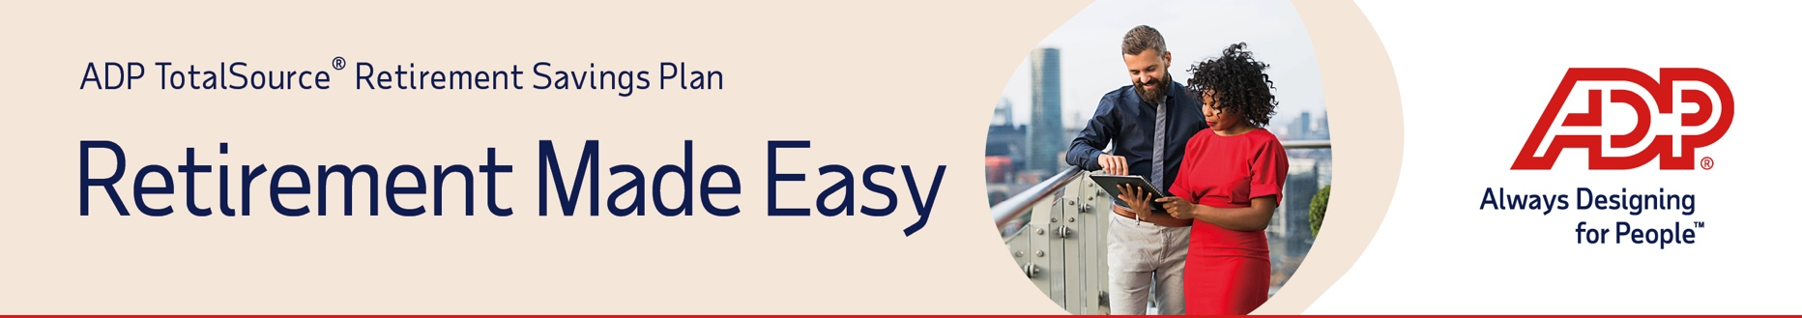
Important information about the ADP TotalSource Retirement Savings Plan

We are pleased to inform you that an automatic enrollment feature has been added to the 401(k) plan. This means that if you meet the eligibility requirements, you will be automatically enrolled in the plan unless you choose to opt out. If you are already participating in the ADP TotalSource Retirement Savings Plan, your current contribution(s) will remain in place, and no action will be required.

Eligible employees will receive enrollment materials from Voya. These enrollment materials will contain your unique “opt-out” date, which is the date by which you must take action on your account if you do not wish to make contributions to your retirement savings plan.

How it works:

Automatic Enrollment: if you do not act by the opt-out date stated in your enrollment materials, X% of your eligible compensation will be automatically deducted from your paycheck and contributed to your 401(k) account. These auto enrollment contributions will be invested in a default investment option selected by the plan unless you choose other investment options.

Timing of Contributions: If you want to start saving as soon as possible, it’s recommended that you make a personalized election instead of waiting for automatic enrollment to occur. You can select a rate between 1%-99% of your eligible compensation. If you actively enroll in the plan before the auto enrollment opt-out date you will see your first 401(k) contribution in the first paycheck date in the month following the month in which you complete the plan eligibility requirements. If you have already met the eligibility requirements you will see your elected personalized rate within 1-2 pay periods.

If you do not actively enroll before the auto enrollment opt-out date and prefer to be auto enrolled, you will be enrolled in the default contribution rate noted above with payroll deductions occurring after the auto enrollment opt-out date has passed.

Automatic Deferral Increase: Your contribution rate will automatically increase by 1% each year, up to a maximum of 15% of your pay, unless you elect to opt out or modify the deferral rate.

Opting Out: To prevent the 401(k) deduction from being withheld from your pay, you should decline enrollment prior to the opt out date in your enrollment materials. If you decide you would like to start contributing to your retirement savings plan in the future, you can update your election at any time through your Voya account online or over the phone.

We encourage you to review the plan details included in the enrollment guide sent to you and take advantage of this opportunity to build your retirement savings. Additional resources regarding your plan are located on the Participant Resources website, including Account Access Instructions and a video that will walk you through the Enrollment Process. You can review the Auto Enrollment Resources section of the site for additional information on this plan feature.

For additional questions or to make an account transaction over the phone, please call the Voya Plan Service Center at (855) 646-7549. Voya is available from 8:00am to 8:00pm Eastern Time, Monday through Friday (excluding New York Stock Exchange holidays).

Thank you

